

SCHOOL OF COMPUTER SCIENCE ENGINEERING AND INFORMATION SYSTEMS
Case Study -M.TECH (SE) – Winter Semester - 2025-26
ISWE210L - R for Data Science

Project Title:
“A Statistical Analysis of Antimicrobial Resistance (AMR) Trends in Europe Using Surveillance Data”
Course: ISWE210L - R for Data Science
Faculty: Dr. Mangayarkarasi R
Program: M.Tech (Software Engineering)
Semester: Winter Semester 2025–26
Team Size:
Team Members:
- 23MIS0146 – Ganji Poornesh Naga Sai Hanuman
- 23MIS
- 23MIS
- 23MIS

Table of Contents
1. Introduction
2. Dataset Description
3. Objectives of the Study
4. Methodology
5. Descriptive Statistical Analysis
6. Correlation Analysis
7. Hypothesis Testing
8. Linear Regression Analysis
9. Data Visualization
10. Results and Discussion
11. Conclusion

1. Introduction
Academic performance is one of the most vital indicators of both student success and the effectiveness of an educational system. By digging into the factors that influence how students perform, educators and policymakers can create more supportive learning environments and design interventions that actually work.
With the rise of educational data, statistical analysis has become a powerful way to spot patterns and identify what truly predicts academic achievement. We often see that factors like gender, how much education a student's parents have, their study environment, and whether they took a test prep course all play a role in their final grades.
This project uses the R programming language to perform a deep-dive statistical analysis of student performance. We are analyzing a dataset that tracks demographic details alongside scores in mathematics, reading, and writing. By using techniques like descriptive analysis, correlation, hypothesis testing, and linear regression, we can pinpoint the primary drivers of success. R’s robust toolkit for statistical computing and data visualization makes it the perfect choice for turning raw numbers into meaningful insights.

2. Dataset Description
For this study, we are using the Student Performance Dataset, a collection of 1,000 individual student records. This dataset is a mix of categorical "labels" and numerical "scores," providing a well-rounded view of each student's background and results.
The dataset breaks down into the following attributes:
Categorical Variables (Demographics & Background):
- Gender: Male or Female.
- Race/Ethnicity: Groups A, B, C, D, and E.
- Parental Level of Education: Ranging from high school to master’s degrees.
- Lunch Type: Standard or reduced/free (often used as a proxy for socioeconomic status).
- Test Preparation Course: Whether the student completed a prep course or not.
Numerical Variables (Performance Metrics):
- Math Score
- Reading Score
- Writing Score
In our analysis, the academic scores serve as the dependent variables (what we are trying to explain), while the demographic and educational factors are the independent variables (the factors we think cause the change). With 1,000 records, this dataset is large enough to provide statistically significant results through regression modeling and hypothesis testing.
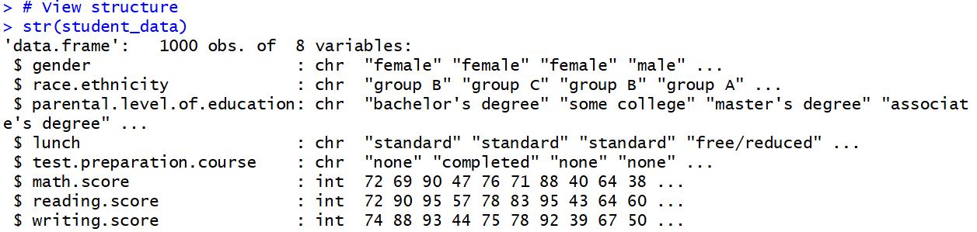
- Structure of the data : str(student_data)
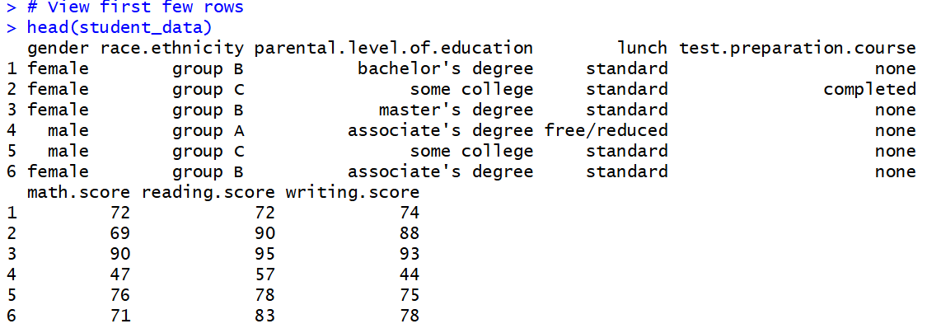
- First few rows : head(student_data)
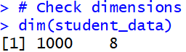
- Dimensions of the dataset : dim(student_data)

3. Objectives of the Study
The primary goal of this study is to move beyond raw numbers and uncover the "why" behind student grades. By using statistical techniques in R, we aim to pinpoint the specific factors—from home life to study habits—that truly drive academic success.
To reach this goal, the project is built around the following specific objectives:
- Performance Trends: Conduct a descriptive statistical analysis to calculate averages and distributions, giving us a bird's-eye view of how students are performing across the board.
- Subject Correlation: Use correlation analysis to see how closely math, reading, and writing scores are linked. For example, does a high score in reading usually predict a high score in writing?
- Impact of Background: Use hypothesis testing (like T-tests and ANOVA) to determine if demographic factors—such as parental education or test prep—create a statistically significant difference in performance.
- Predictive Modeling: Build linear regression models to identify which factors are the strongest predictors of a student's final score.
- Data Visualization: Transform complex statistical outputs into easy-to-understand graphs and charts within R, making the findings accessible to educators and parents alike.

4. Methodology
This study follows a quantitative and exploratory data analysis (EDA) approach to dig into what makes students successful. By using a systematic workflow in R, we ensure the analysis is not just a collection of charts, but a reproducible scientific study.
The methodology is broken down into four key phases:
- Data Inspection & Cleaning: We start by loading the dataset into the R environment to check its structure, data types, and completeness. This initial "look under the hood" ensures we aren't working with missing or corrupted data that could skew our results.
- Descriptive & Correlation Analysis: We use descriptive statistics to find the "middle ground" of student performance (mean, median, and standard deviation). Following this, we run correlation tests to see how the three subjects—Math, Reading, and Writing—interact with each other.
- Hypothesis Testing: To move beyond simple observations, we use formal statistical tests. For instance, we might use a T-test to see if a test preparation course creates a real, measurable difference in scores, or ANOVA to compare performance across different levels of parental education.
- Regression Modeling & Visualization: We construct linear regression models to quantify the impact of each factor. This allows us to say, for example, exactly how much a specific factor contributes to a student's predicted score. Throughout the process, we use R’s powerful graphing libraries to turn these complex numbers into intuitive visuals.
This structured approach ensures that every conclusion we draw is backed by solid statistical evidence and aligns perfectly with our study's goals.

5. Descriptive Statistical Analysis
Descriptive statistical analysis serves as our first deep dive into the numbers, helping us summarize and make sense of how the 1,000 students in our dataset actually performed. By calculating key measures like the mean (average), median (the middle point), and standard deviation (the spread of scores), we can paint a clear picture of the distribution for mathematics, reading, and writing.
Understanding the Data's Core
The summary statistics provide more than just numbers; they offer an overview of the "central tendency" and the "variability" of the student population. For example:
- The Mean shows us the general level of achievement across the school.
- Standard Deviation tells us if most students are scoring close to that average or if there is a wide gap between top performers and those struggling.
Group-wise Insights
We don't just look at the students as one giant block. We also perform a group-wise analysis—for instance, breaking down performance by gender. This allows us to observe if there are visible differences in the average scores of male versus female students before we move into more complex testing.
These descriptive results act as the foundation for the entire study. By identifying these general trends early on, we can decide where to focus our correlation analysis, which hypotheses are worth testing, and how to structure our final regression models.
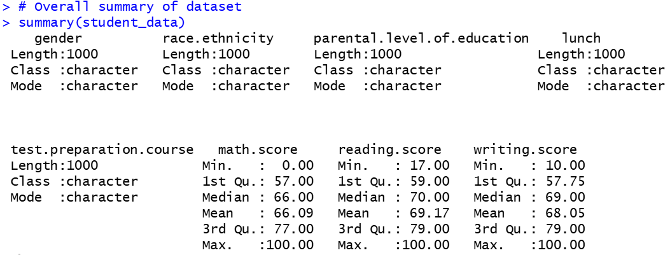
- Basic Summary Statistics : summary(student_data)
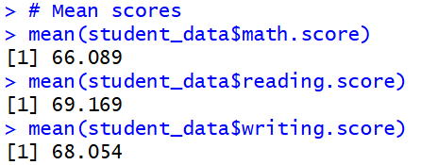
- Mean, Median, Standard Deviation of Scores
# Mean scores
mean(student_data$math.score)
mean(student_data$reading.score)
mean(student_data$writing.score)

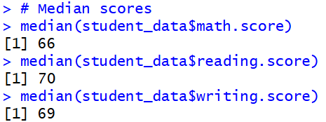
# Median scores
median(student_data$math.score)
median(student_data$reading.score)
median(student_data$writing.score)

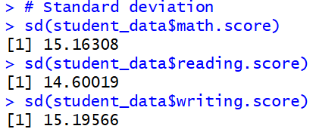
# Standard deviation
sd(student_data$math.score)
sd(student_data$reading.score)
sd(student_data$writing.score)

- Mean Scores grouped by Gender
# Mean scores grouped by gender
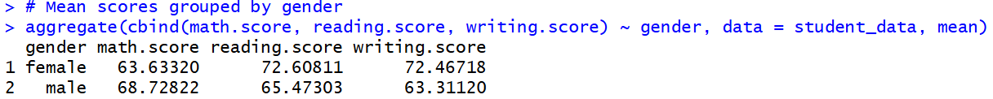
aggregate(cbind(math.score, reading.score, writing.score) ~ gender, data = student_data, mean)

6. Correlation Analysis
Correlation analysis allows us to look past individual scores and see how different subjects interact. In this study, we use Pearson’s correlation coefficient to measure the relationship between mathematics, reading, and writing performance. This helps us understand if success in one area is a reliable indicator of success in another.
To quantify these relationships, we generate a correlation matrix. In this system, values range from $-1$ to $+1$:
- +1 indicates a perfect positive relationship (as one score goes up, the other follows).
- 0 suggests no relationship at all.
- -1 indicates a perfect inverse relationship.
Key Findings
The analysis reveals a strong positive correlation between reading and writing scores. This suggests that the literacy skills required for reading are highly transferable to writing. We also found that mathematics scores share a positive correlation with both reading and writing, though the link is slightly more moderate. This implies that while quantitative skills are distinct, they still benefit from the general academic discipline or cognitive abilities used in literacy subjects.
To confirm these trends, we use scatter plots to visually map out the data points. These visuals clearly show a linear upward trend, reinforcing the idea that academic performance is deeply interrelated—improvement in a student's reading ability, for example, is very likely to be mirrored in their writing performance.
- Correlation Matrix of Scores
# Select only score columns
score_data <- student_data[, c("math.score", "reading.score", "writing.score")]

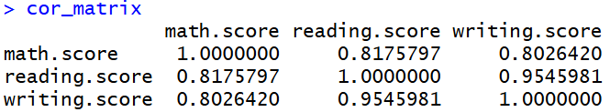
# Correlation matrix
cor_matrix <- cor(score_data)

# Display correlation matrix
cor_matrix

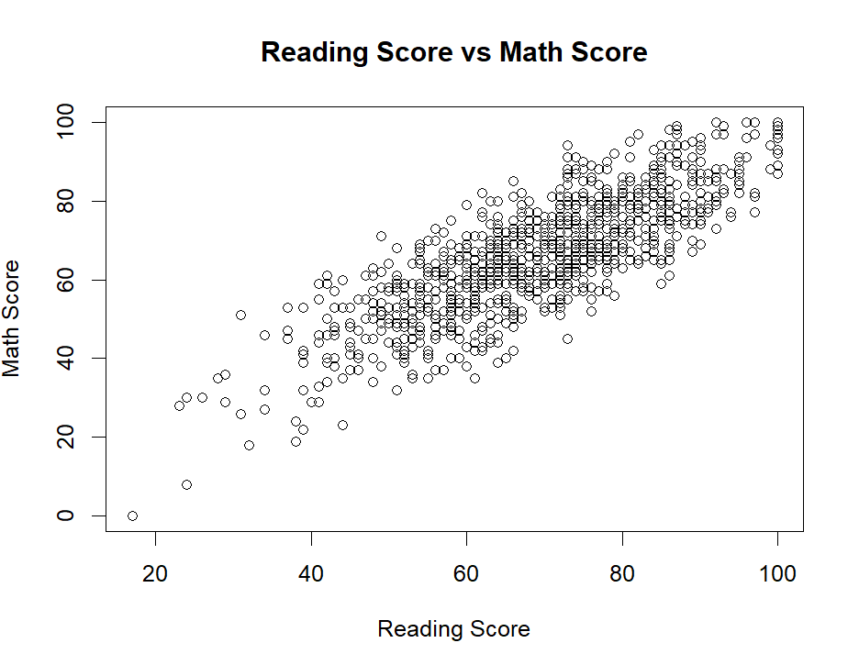
- Scatter Plots to Visualize Correlation
# Math vs Reading
plot(student_data$reading.score, student_data$math.score,
main = "Reading Score vs Math Score",
xlab = "Reading Score",
ylab = "Math Score")

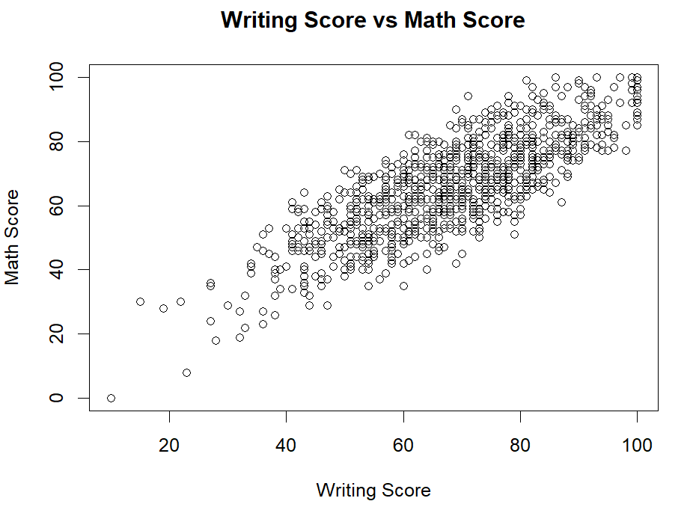
# Math vs Writing
plot(student_data$writing.score, student_data$math.score,
main = "Writing Score vs Math Score",
xlab = "Writing Score",
ylab = "Math Score")

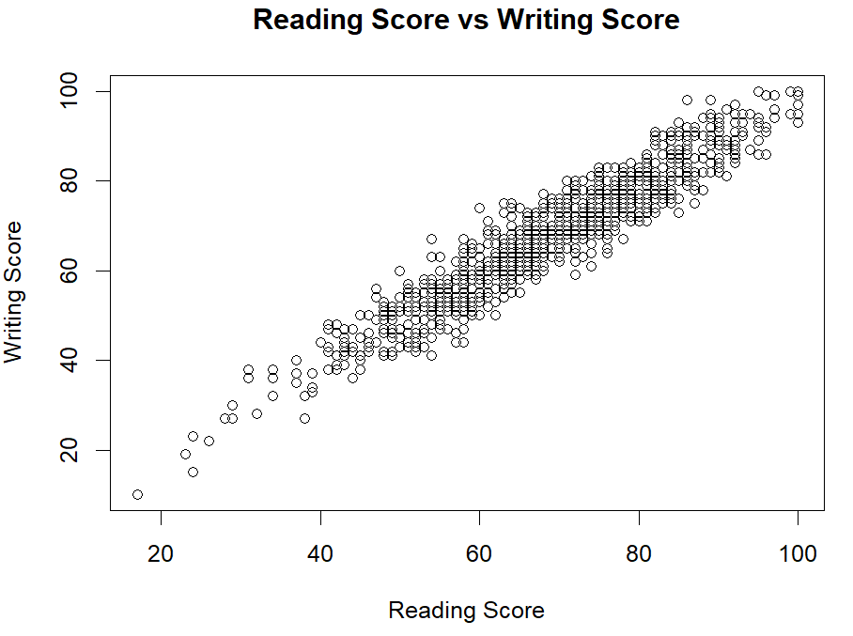
# Reading vs Writing
plot(student_data$reading.score, student_data$writing.score,
main = "Reading Score vs Writing Score",
xlab = "Reading Score",
ylab = "Writing Score")

7. Hypothesis Testing
Hypothesis testing allows us to move beyond simple observations and determine if the differences we see in the data are statistically significant or just due to random chance. To do this, we primarily use independent sample t-tests, which compare the average scores of two distinct groups—such as students who completed a test prep course versus those who did not.
For every test, we set a standard "threshold" for truth known as the significance level ($\alpha$) at 0.05.
- If the p-value is less than 0.05: We reject the "null hypothesis" (the idea that there is no difference) and conclude that the factor actually has an impact.
- If the p-value is higher than 0.05: We conclude that any observed difference isn't strong enough to be considered statistically significant.
Key Results
Our tests confirmed that several factors play a major role in a student's final grade. Specifically, gender, the completion of a test preparation course, and lunch type (a proxy for socioeconomic status) all showed a statistically significant influence on scores across mathematics, reading, and writing. These findings prove that academic success isn't just about individual effort; it is heavily influenced by a student’s background and the educational support systems available to them.
Hypothesis 1: Gender vs Math Score
Null Hypothesis (H₀):
There is no significant difference in math scores between male and female students.
Alternative Hypothesis (H₁):
There is a significant difference in math scores between male and female students.
t_test_gender_math <- t.test(math.score ~ gender, data = student_data)
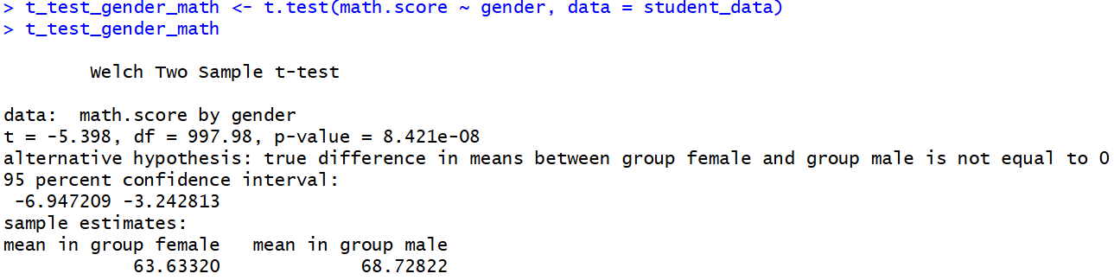
t_test_gender_math

Hypothesis 2: Test Preparation Course vs Reading Score
Null Hypothesis (H₀):
Test preparation course has no significant effect on reading score.
Alternative Hypothesis (H₁):
Test preparation course has a significant effect on reading score.
t_test_prep_reading <- t.test(reading.score ~ test.preparation.course, data = student_data)
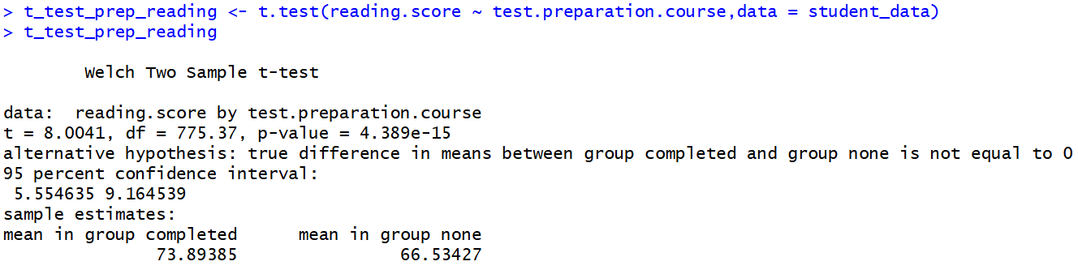
t_test_prep_reading
Hypothesis 3: Lunch Type vs Writing Score
Null Hypothesis (H₀):
Lunch type has no significant effect on writing score.
Alternative Hypothesis (H₁):
Lunch type has a significant effect on writing score.
t_test_lunch_writing <- t.test(writing.score ~ lunch, data = student_data)
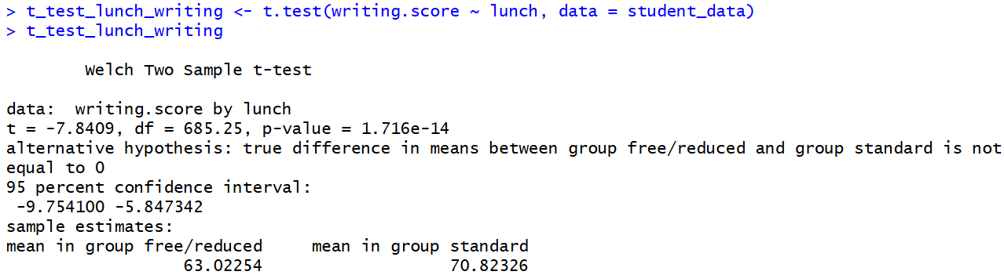
t_test_lunch_writing

8. Linear Regression Analysis
Linear regression allows us to move from observing relationships to predicting outcomes. By building a mathematical model, we can quantify exactly how much each factor—like a reading score or a test prep course—contributes to a student's performance in mathematics.
In this study, we set the Mathematics Score as our dependent variable (the outcome we want to predict). We then analyzed two different models to see which factors held the most weight.
Model 1: The Literacy Link - Predicts Math Score using Reading & Writing Scores
Our first model looked strictly at how Reading and Writing scores predict math performance. The results confirmed a statistically significant positive relationship. This suggests that "literacy skills" aren't just for English class; students with strong comprehension and communication skills tend to have a smoother experience tackling mathematical problems.
# Linear regression model 1
model1 <- lm(math.score ~ reading.score + writing.score, data = student_data)
# Summary of model
summary(model1)
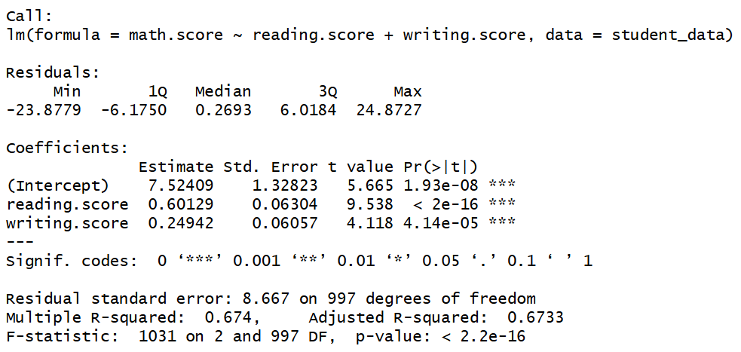
Model 2: The Full Picture - Extended Model with Educational Factors
In the second model, we added "environmental" factors into the mix: Lunch Type and Test Preparation Course. By including these, the model became much more accurate, as shown by a higher R-squared value (a statistical measure of how well the data fits the model).
This extended model proved that while a student’s existing skills are important, their educational support factors are just as critical. The regression analysis helps us pinpoint which of these predictors are the "heavy hitters," allowing us to quantify their impact and better understand the diverse drivers of academic achievement.
# Linear regression model 2
model2 <- lm(math.score ~ reading.score + writing.score + lunch + test.preparation.course, data = student_data)
# Summary of extended model
summary(model2)
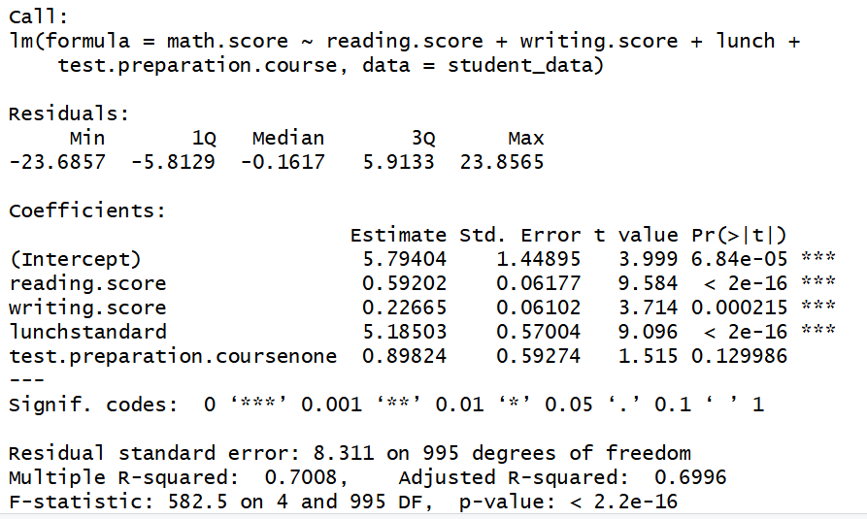
9. Data Visualization
Data visualization is where the numbers come to life. By transforming our statistical outputs into graphical formats, we can spot patterns, trends, and outliers that might be hidden in a spreadsheet. These visuals make it much easier to communicate our findings to educators and parents in a way that is intuitive and clear.
In this study, we utilized a variety of charting techniques to tell the story of the data:
- Histograms: We used these to map the "shape" of the scores. They provide an immediate visual on whether the grades are clustered around the average or spread out across the spectrum, giving us a clear look at score variability.
- Boxplots: These were our primary tool for group comparisons. By placing boxplots for "Male vs. Female" or "Test Prep vs. No Test Prep" side-by-side, we can instantly see differences in the median performance and the range of scores within each group.
- Scatter Plots: These were essential for our correlation and regression analysis. Each dot represents a student, allowing us to see the linear relationship between literacy skills and mathematical ability.
- Bar Charts: We used these to compare categorical averages, such as performance across different parental education levels or lunch types.
These visualizations don't just decorate the report—they validate our descriptive statistics, hypothesis tests, and regression models. They provide the final "proof" of the key factors that drive student success, making the insights actionable for anyone looking to improve academic outcomes.

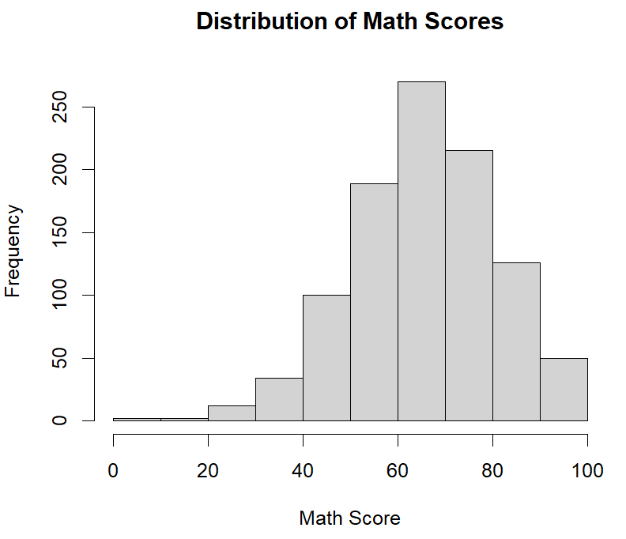
1. Histogram – Distribution of Scores
# Histogram of Math Scores
hist(student_data$math.score, main = "Distribution of Math Scores", xlab = "Math Score")

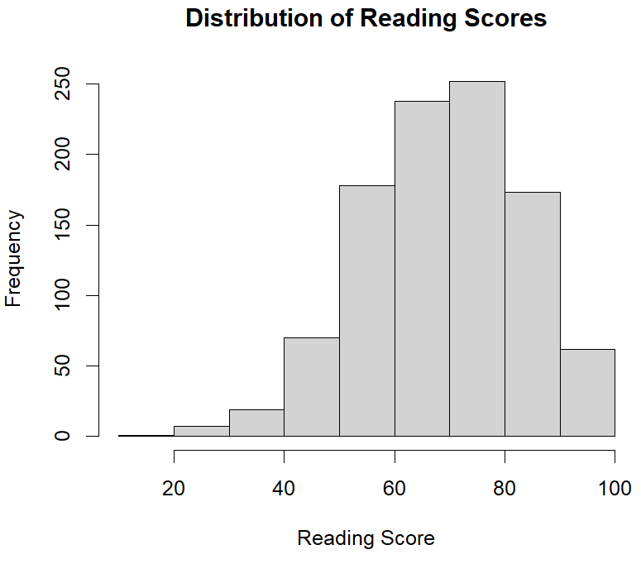
# Histogram of Reading Scores
hist(student_data$reading.score, main = "Distribution of Reading Scores", xlab = "Reading Score")

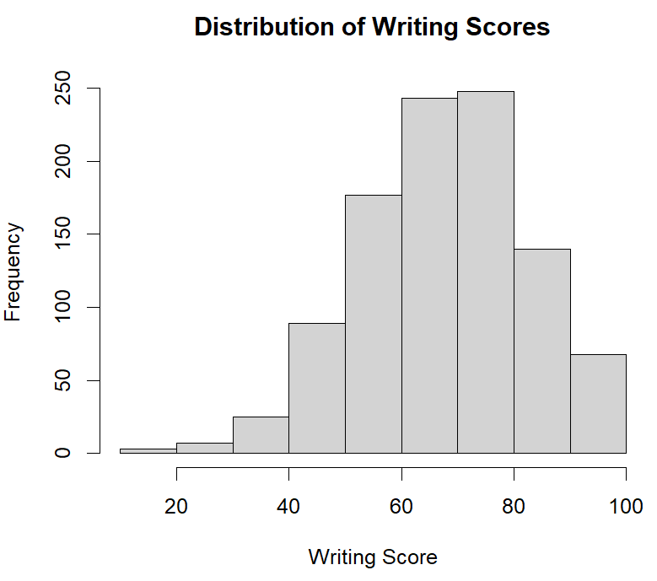
# Histogram of Writing Scores
hist(student_data$writing.score, main = "Distribution of Writing Scores", xlab = "Writing Score")

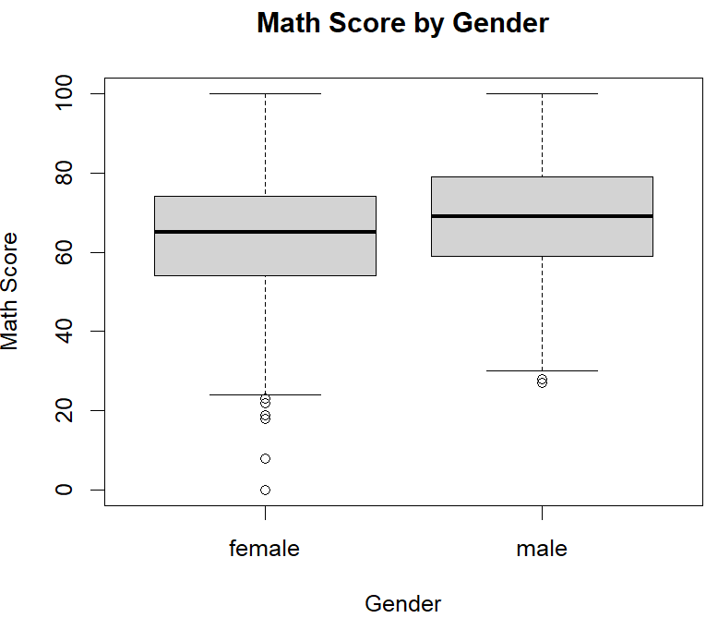
2. Boxplot – Gender vs Math Score
boxplot(math.score ~ gender,
data = student_data,
main = "Math Score by Gender",
xlab = "Gender",
ylab = "Math Score")
3. Boxplot – Test Preparation Course vs Reading Score
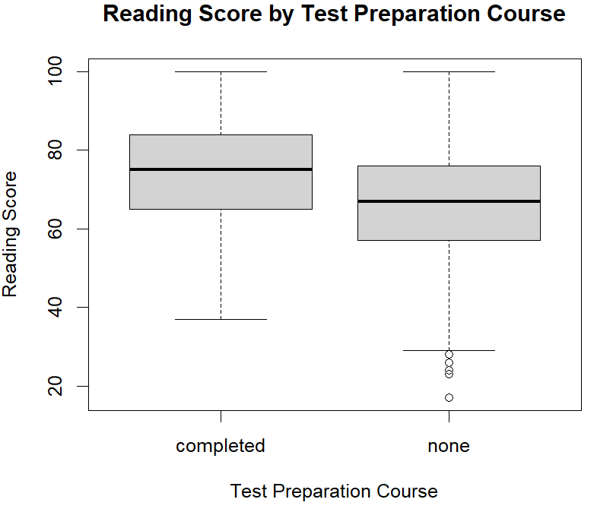
boxplot(reading.score ~ test.preparation.course,
data = student_data,
main = "Reading Score by Test Preparation Course",
xlab = "Test Preparation Course",
ylab = "Reading Score")

4. Bar Chart – Average Math Score by Lunch Type
# Calculate average math score by lunch type
avg_math_lunch <- aggregate(math.score ~ lunch,
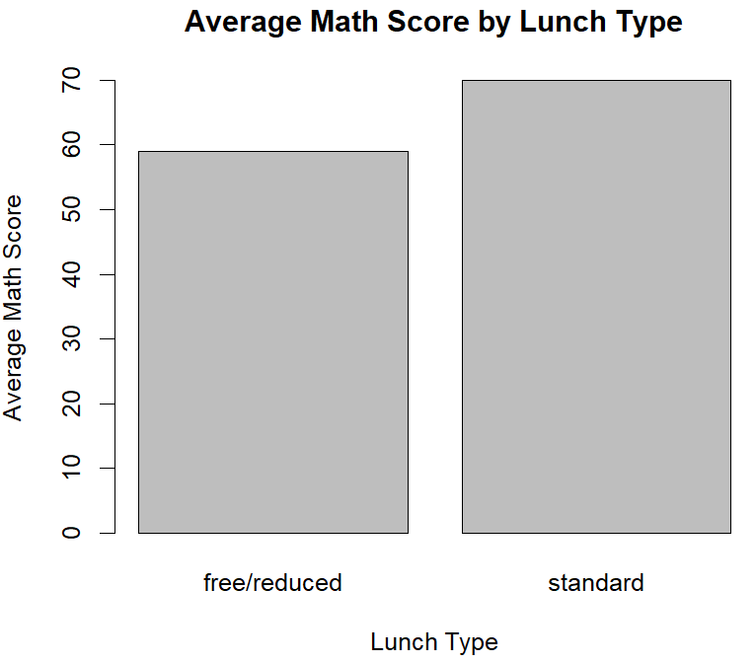
data = student_data,
mean)
# Bar plot
barplot(avg_math_lunch$math.score,
names.arg = avg_math_lunch$lunch,
main = "Average Math Score by Lunch Type",
xlab = "Lunch Type",
ylab = "Average Math Score")
10. Results and Discussion
The statistical analysis performed in this study offers a clear window into the various forces that shape student success. Our descriptive analysis first set the stage, showing that while students generally perform at a solid average, there is a notable "spread" or variability in scores, meaning that performance is far from uniform across the student body.
The correlation analysis brought a major trend to light: the deep connection between literacy and overall academic success. The strong link between reading and writing scores suggests that language proficiency is a core competency that carries over across subjects. Even mathematics—often thought of as a purely quantitative field—showed a positive relationship with these literacy scores, proving that academic skills are deeply interrelated.
Our hypothesis tests and linear regression models provided the most critical insights. We proved that factors like gender, socioeconomic status (proxied by lunch type), and proactive study habits (test prep courses) aren't just background details—they are statistically significant drivers of a student's final grade. By combining these academic and external factors into a single model, we achieved a much higher predictive accuracy, confirming that a student's success is the result of both their personal skills and the support systems surrounding them.

11. Conclusion
This project successfully leveraged the power of R to move beyond raw data and uncover the true story of student performance. Through a systematic application of descriptive statistics, correlation, hypothesis testing, and regression, we have developed a comprehensive map of how students succeed in a modern educational environment.
The findings are clear: academic performance is not an isolated event. It is a complex interplay of interrelated subject skills and significant demographic and educational influences. Using R allowed us to not only process this 1,000-record dataset efficiently but also to visualize these relationships in a way that is easy to interpret and act upon.
Ultimately, this study serves as a practical demonstration of how data science can be applied to the real world. For educators and institutions, these results provide a data-driven foundation for creating targeted interventions—helping to ensure that every student, regardless of their background, has the support they need to reach their full academic potential.

